

本科实验报告

课程名称： | 计算机组成
姓 名： | 王俊
学 院： | 海洋学院
专 业： | 海洋工程与技术
学 号： | 3170100186
指导教师： | 姜晓红

2020年 5 月 7 日

报告实验7—CPU设计-指令集扩展

课程名称： 计算机组成 实验类型： 综合
实验项目名称： 集成替换CPU核

学生姓名： 王俊 专业： 海洋工程与技术 学号： 3170100186
同组学生姓名： 指导老师： 姜晓红
实验地点： 家里 实验日期： 2020 年 5 月 7 日

一、实验目的和要求
1. Using register transfer control technology
2. Master the core of the CPU: the relationship between the instruction execution process and the control flow
3. Design data path and controller
4. Design test procedures

experiment apparatus:
- Computer (Intel Core i5 or higher, 4GB RAM or higher) system
- Spartan-3 Starter Kit Board / Sword development board
- Xilinx ISE 14.4 and above development toolsExperimental Materials：
No

- 实验内容和原理
2.1.Experimental task：
1. Extended experiment 6 CPU instruction set
Redesigned data path and controller
Compatible with Exp05 data path and controller
Replace the Exp05 data path controller core
No less than the following instructions
R-Type: add, sub, and, or, xor, nor, slt, srl *, jr, jalr, eret;
I-Type: addi, andi, ori, xori, lui, lw, sw, beq, bne, slti
J-Type: J, Jal *;
This experiment was completed on the basis of Exp06
2. Design instruction set test plan
3. Design instruction set test program
2.2.Computer Architecture
2.2.1.Computer system decomposition
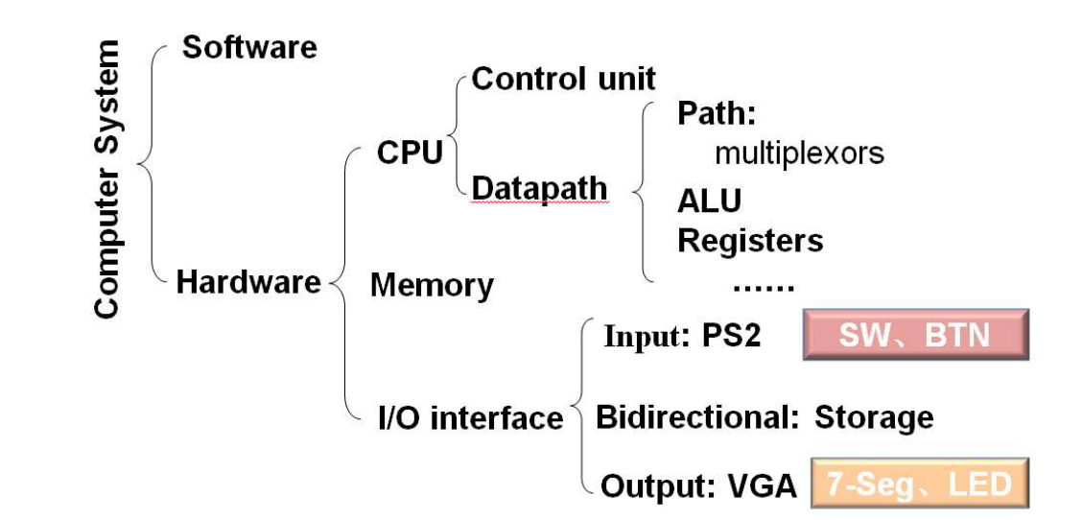

Digital circuits vs CPU organization :
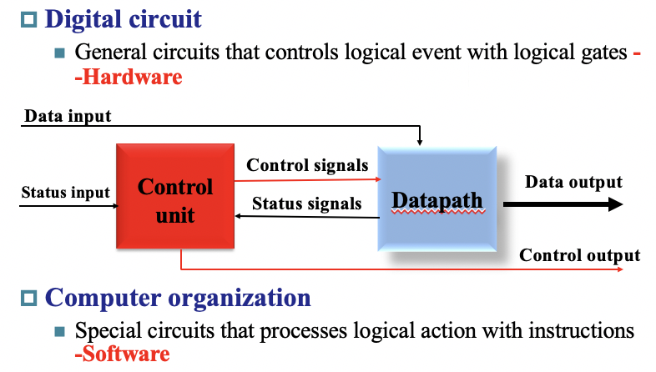
- Control signal definition：
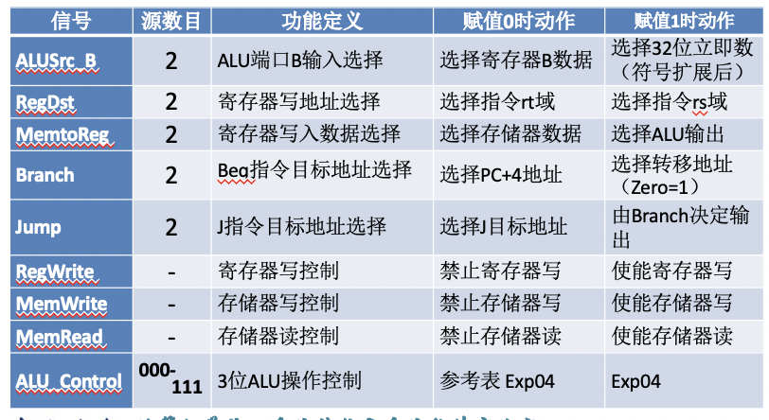

- Interface redesign
---After expansion, the control signal is added
---The data path reference interface is shown on the right
Module symbol documentation: Dataa_path_more.sym
---The controller reference interface signal is shown in the figure below
Module symbol document: SCPU_ctrl_more.sym

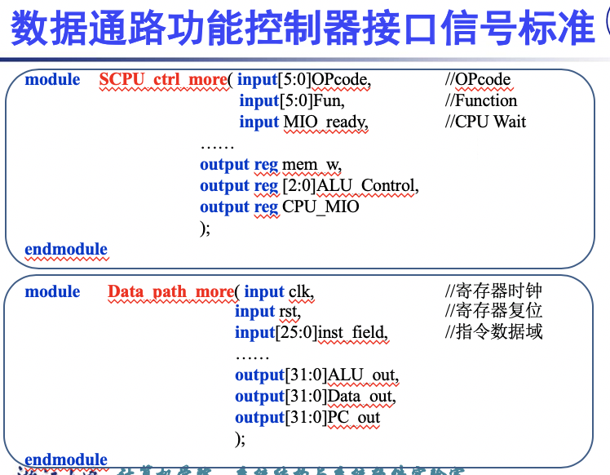

- 实验过程和数据记录
3.1 Design requirements
- No less than the following instructions
R-Type: add, sub, and, or, xor, nor, slt, srl *, jr, jalr, eret;
I-Type: addi, andi, ori, xori, lui, lw, sw, beq, bne, slti
J-Type: J, Jal *;
- New CPU with integrated replacement verification
Replace the SCPU module in Experiment 6 (Exp06)
Replace the SCPU_ctrl module in Experiment 6 (Exp06)
Replace the Data_Path module in Experiment 6 (Exp06)
Module name: Top_OExp06_ExtSCPU.sch
CPU logic symbols need to be modified
- Test the expanded CPU function
Design test program (MIPS assembly) test

4.2 Design points
- DataPath structure after design instruction expansion
Logic symbols need to be redesigned based on new interface signals
Expand on the schematic of Experiment 5
- Design the controller according to the new DataPath structure
Logic symbols need to be redesigned based on new interface signals
It is recommended to use HDL structured description
- Design CPU call module
Design the CPU module according to the new controller and data path interface signals
Redesigned CPU logic symbols
- Simulate newly designed modules
Independent simulation of DataPath and controller
- Integrated replacement of CPU and sub-modules
After the simulation is correct
Integrated replacement of CPU, data path and controller module
Idea:
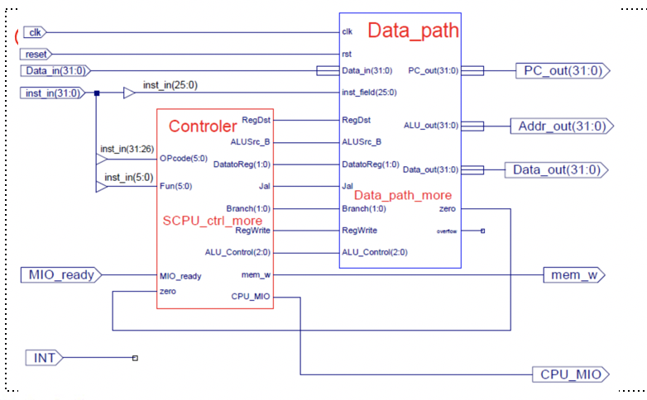
My schematic:
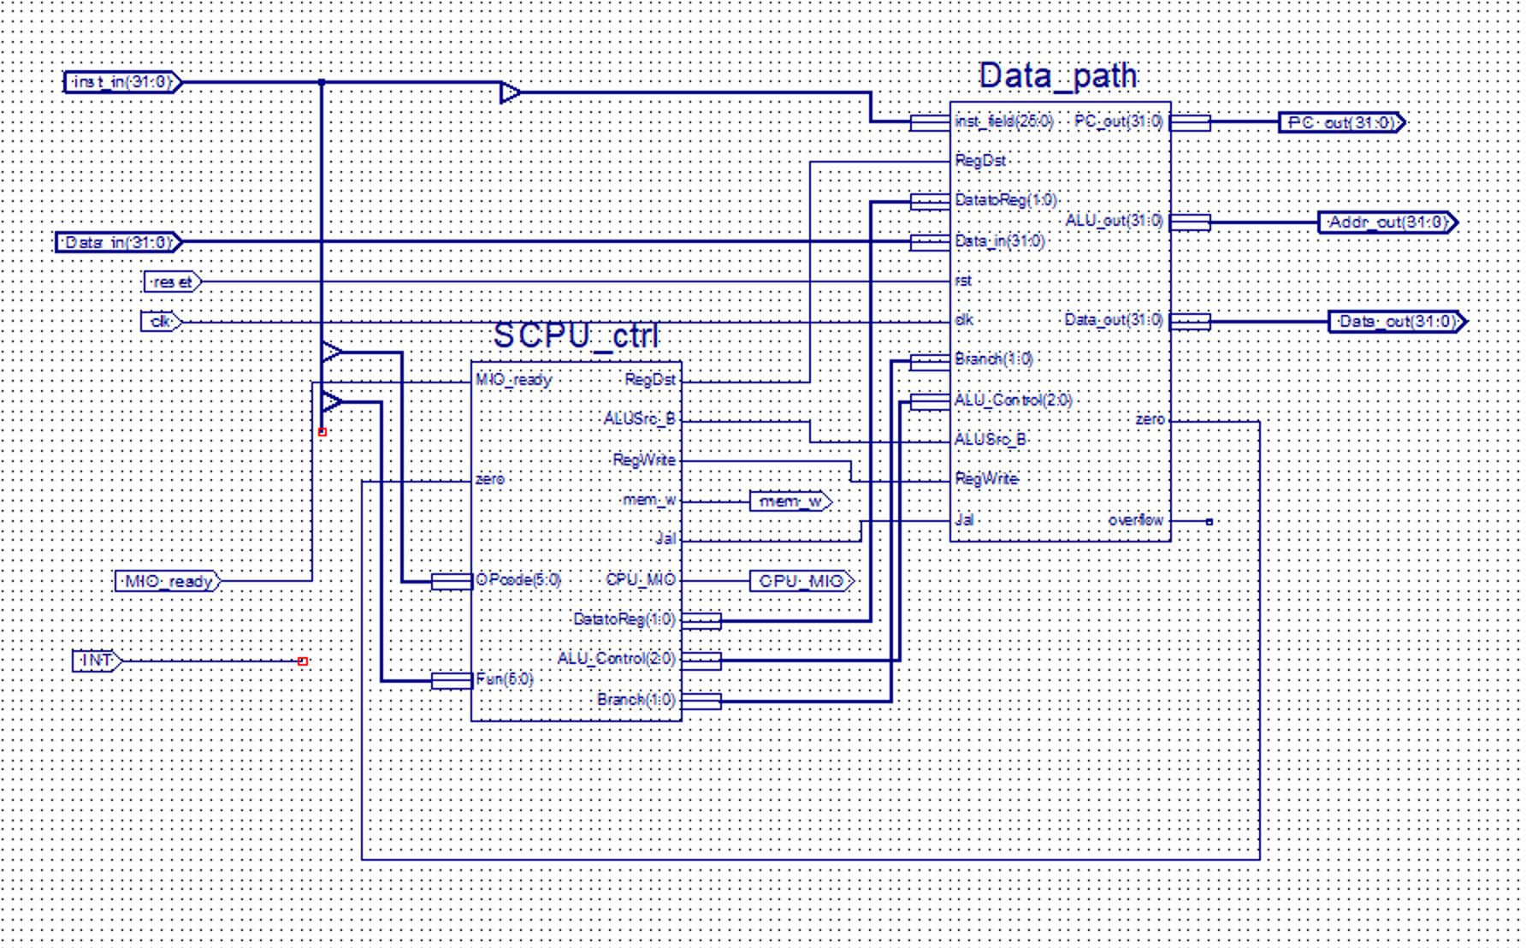
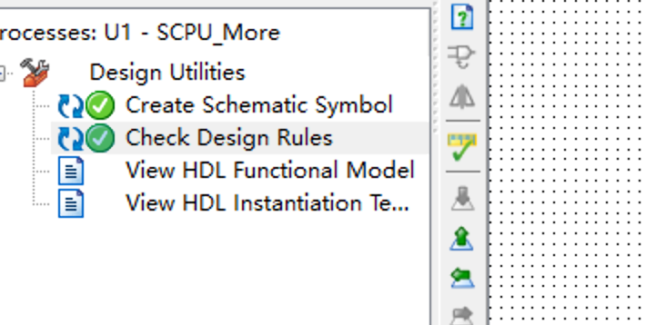
Data-Path:
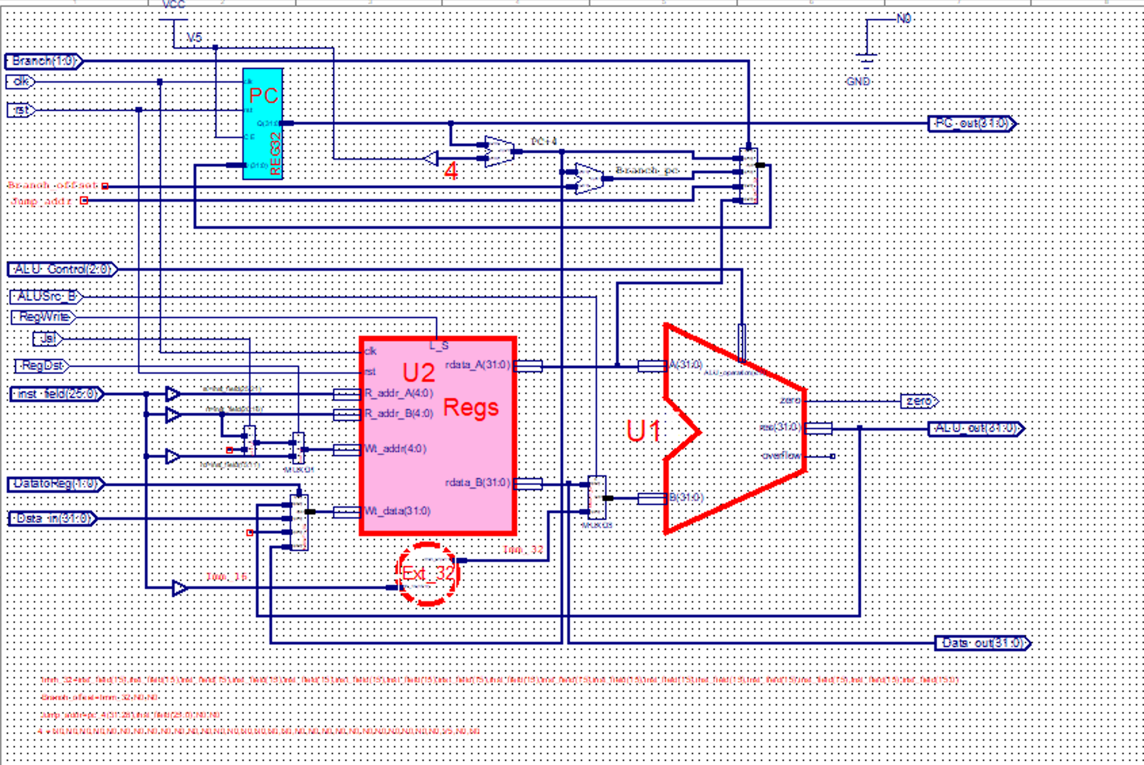
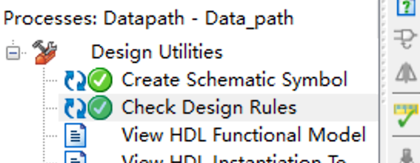
- Define CPU_crtl_signals
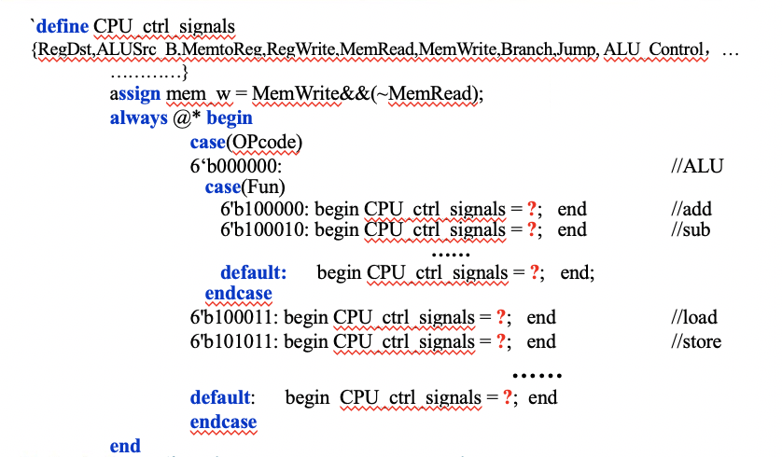

- 实验结果分析
4.1.Test file 1 on SCPU_ctrl_more:
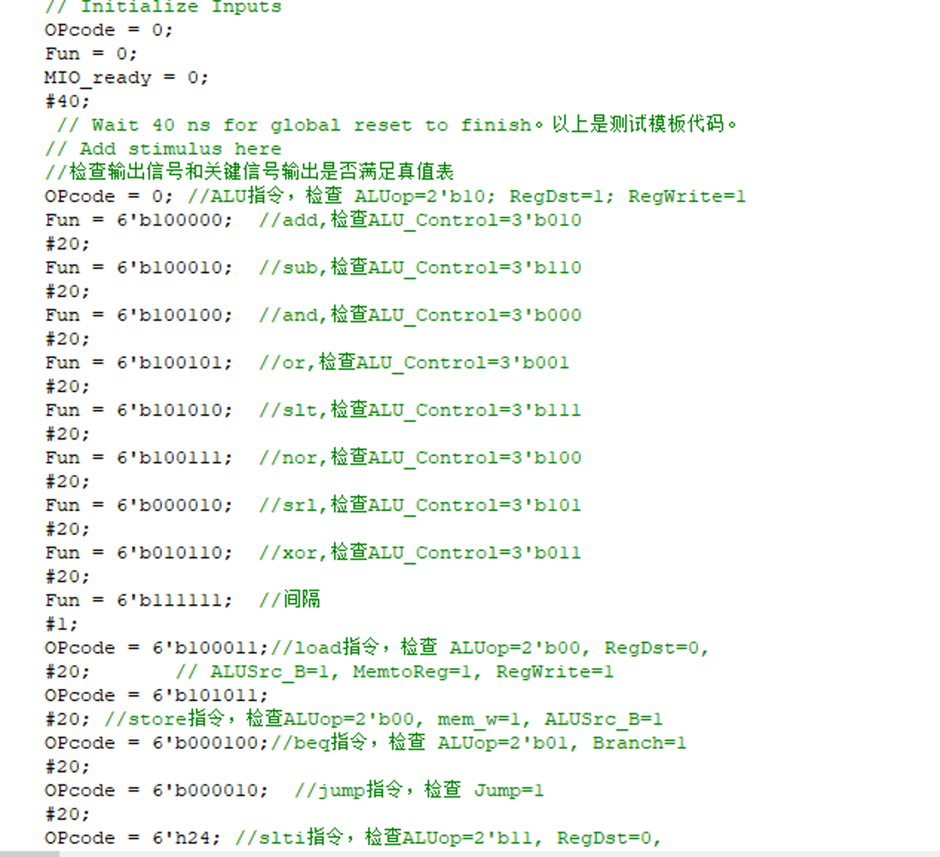
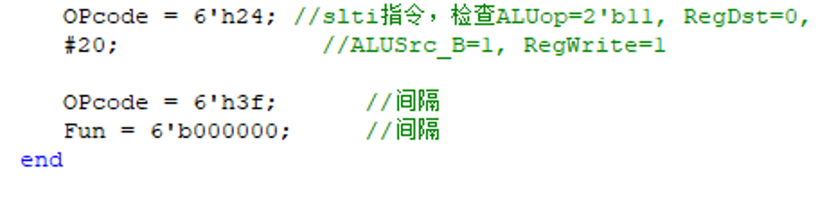
Result:
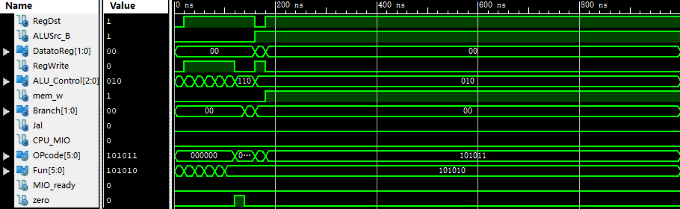

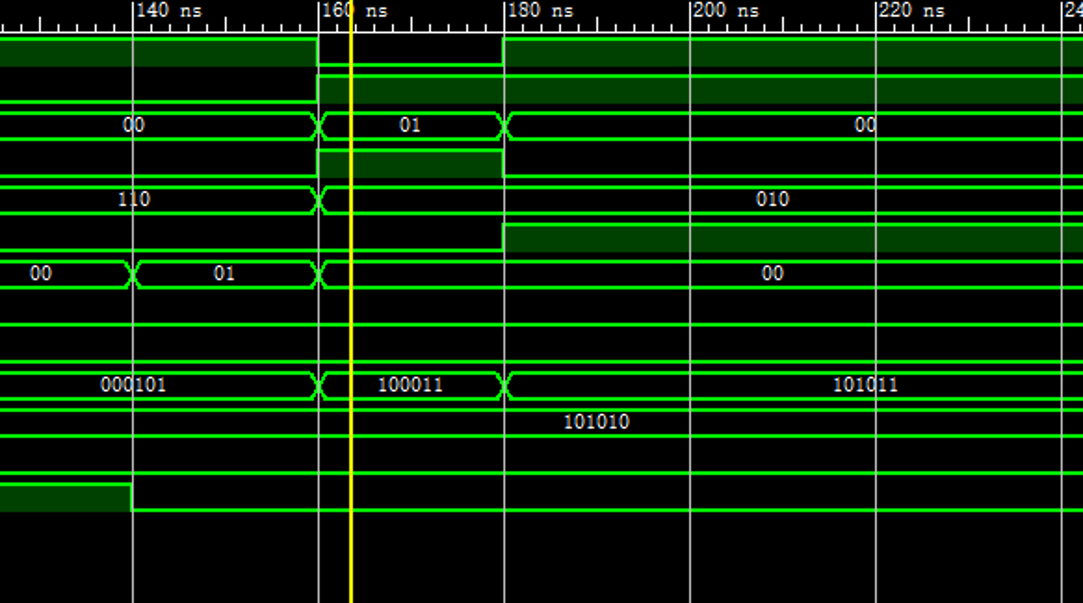

- 实验总结与反思
- This experiment is based on the previous two experiments, and further establishes a CPU debugging test environment, calling SCPU and the IP core of MIO_BUS, and the Counter_X module was written, and the .coe files of RAM and ROM were changed.
With this experiment, the previous foundation has proceeded smoothly, mainly because of a further understanding of the hardware system and SOC. For example, I learned that IP is the soul of SOC, the design basis of SOC is IP multiplexing technology, the type of IP core and so on. Looking forward to follow-up experiments to help us step by step to demystify the modules.
- I have learned how to rename the bus to merge the net together:
If you only use double click to open,you can not rename the same port:
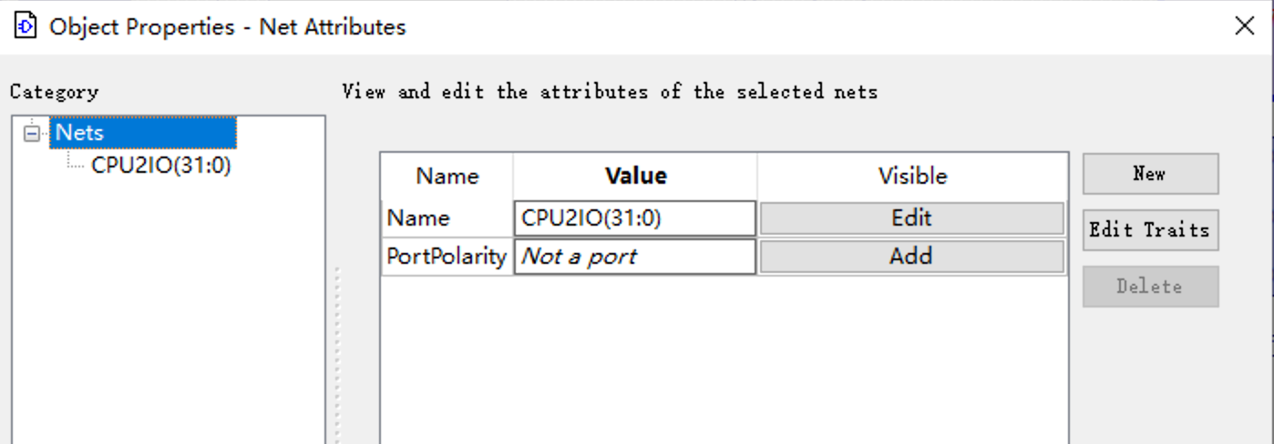
Only if you open in this way you can merge them:
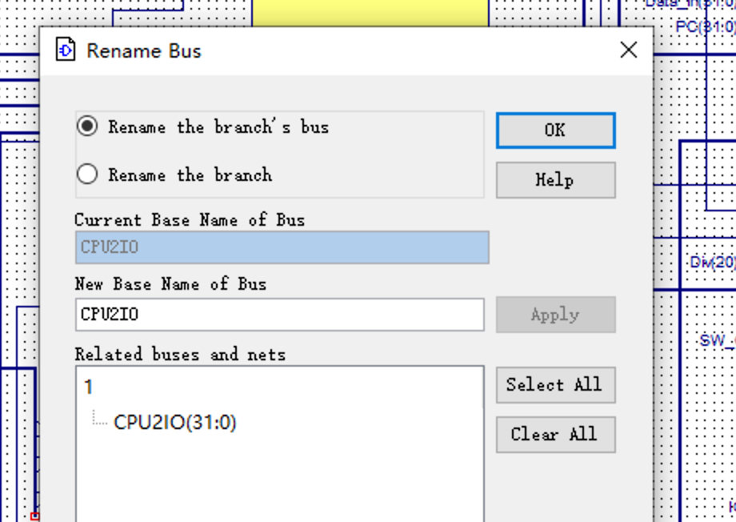
3.Edit symbol to create different symbols,use add square and we can get :
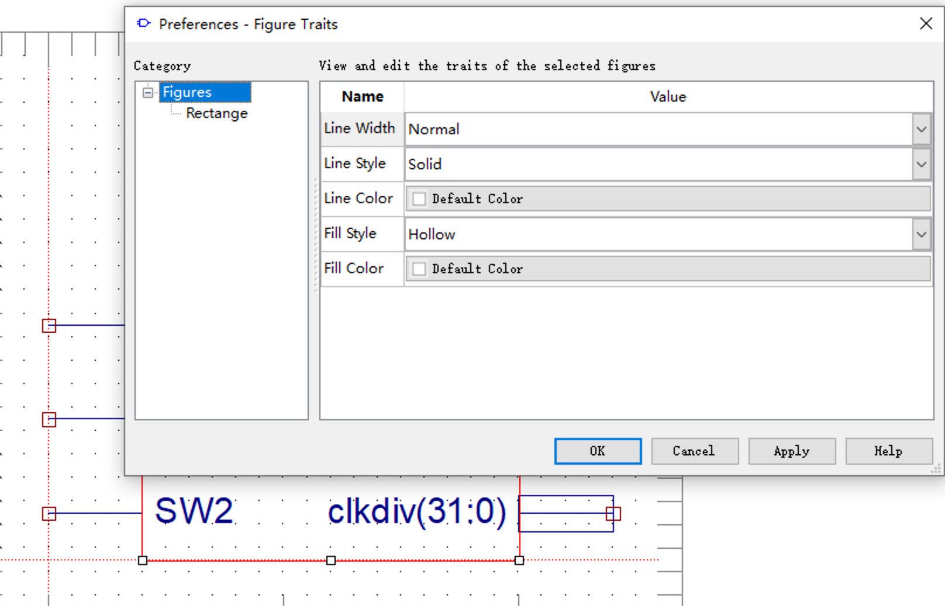
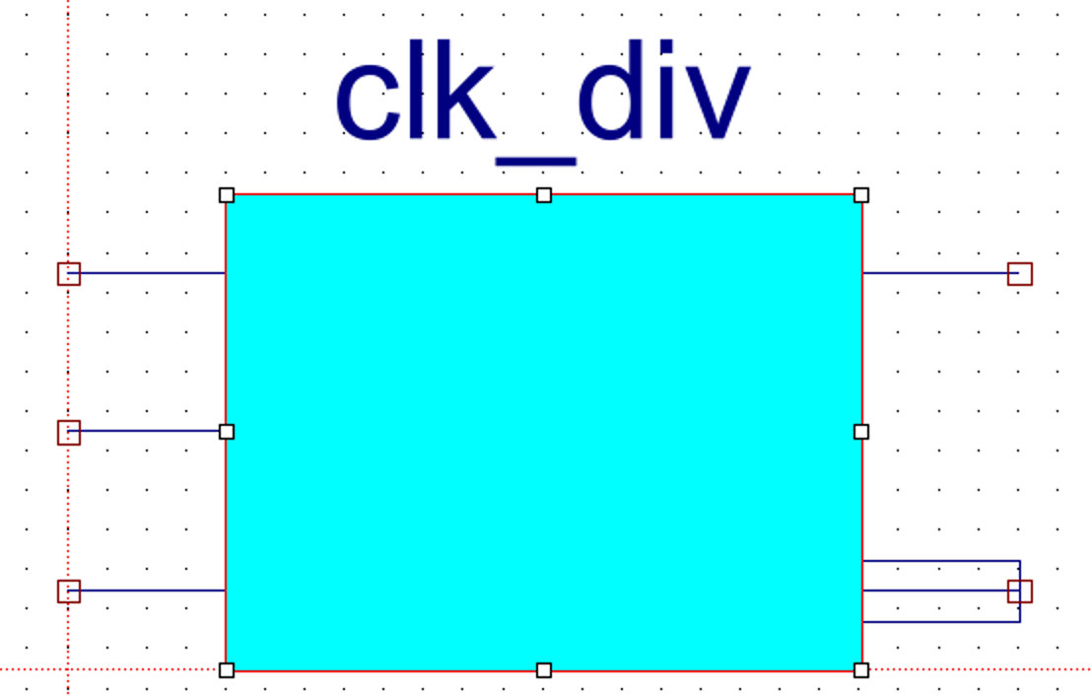
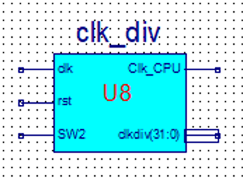

After update, a beautiful model is built:

4.I have learned a lot about the placement and routing.
Layout refers to arranging the designed functional modules on the chip reasonably and planning their positions.
Wiring refers to completing the interconnection between the modules.
The delay between the connection between the modules will seriously affect the performance of the SOC
5.I have learned how to check the schematic:
Tools→Check Schematic
